Experiment 1. First Palindromic String in an Array
Aim: To find the first palindromic string in an array and analyze its time complexity.

Algorithm
- Start.
- Read the number of strings n.
- Read the array of strings words.
- Traverse each string in the array from left to right.
- Compare the first character with the last character.
- Continue comparing characters toward the center.
- If all corresponding characters match, print that string and stop.
- If no palindrome is found, print an empty string "".
- Stop.
C code:
#include <stdio.h>
#include <string.h>
int main() {
int n, i, j, palindrome;
char words[100][100];
printf("Enter number of strings: ");
scanf("%d", &n);
printf("Enter the strings:\n");
for (i = 0; i < n; i++) {
scanf("%99s", words[i]);
}
for (i = 0; i < n; i++) {
palindrome = 1;
int len = strlen(words[i]);
for (j = 0; j < len / 2; j++) {
if (words[i][j] != words[i][len - 1 - j]) {
palindrome = 0;
break;
}
}
if (palindrome) {
printf("Output: %s\n", words[i]);
return 0;
}
}
printf("Output: \"\"\n");
return 0;
}
Input: aba, car, abc, rarace.
Output:
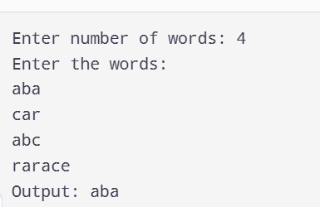

Result:
Thus, the C program to find the first palindromic string in an array was implemented and executed successfully. The program prints the first palindrome found in the array. If no palindrome exists, it prints an empty string.

